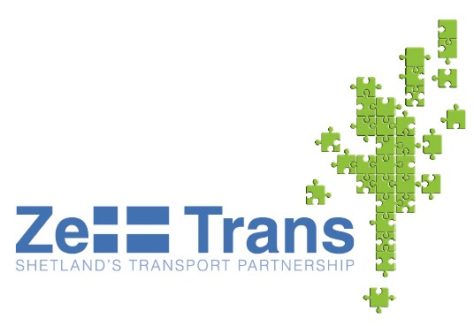
North Isles Area Transport Forum
Monday 13th December
Mid Yell Public Hall
3pm to 5pm
and
6pm to 8pm
Transport to/from Shetland and within Shetland is fundamental to the social and economic wellbeing of our islands.
It is important, therefore, that ZetTrans and the Council’s Transport Service understand what individuals, businesses and communities consider important in the development and delivery of transport services.
To help with this you are invited to an Area Transport Forum covering Yell, Unst and Fetlar to help us develop the way transport is planned and provided.
If you can’t make it that’s not a problem, there are several ways to get involved. These are: -
- Attendance at the Area Transport Forum
- By submitting any ideas and views by post to:
ZetTrans, 20 Commercial Road, Lerwick, ZE1 0LX
- Online at www.zettrans.org.uk
- By phone on 01595 744868
If you would like to attend the forum but are experiencing
difficulties with transport or child care, please phone 01595 744868.

