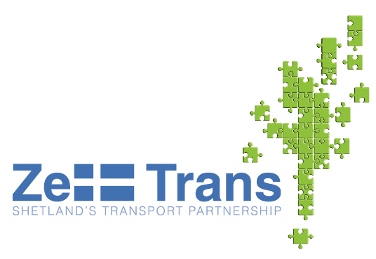
PREVIOUS CONSULTATION INFORMATION SHEET
We have undertaken a review of the outcome of previous recent consultation on issues related to Bluemull Sound.

1. Regional Transport Strategy – Initial Consultation (2005/2006)

This initial consultation was undertaken in order to inform the key issues that required to be addressed by the Regional Transport Strategy.

Overall, consultation revealed a willingness to pursue a fixed link (tunnel) between Yell and Unst. The desirability of a link between Yell and Shetland Mainland was frequently mentioned, but at the time of consultation, Yell Community Council thought the local community was split on the issue.

Community Council Consultation:
Outcomes from discussions with Shetland Mainland Community Councils

- Support was offered for the development of fixed links, particularly to Unst and Yell. It was also suggested if fixed links are going to be built then they should not take as long to implement as the proposed Bressay Bridge. Tunnels were favoured over bridges.
- Better use of electronic signs at ferry terminals to encourage people to visit the outer isles was also stated

North Isles Community Council Consultation

Yell
- Ferry service from Yell to Shetland Mainland was believed to be excellent as there are no problems booking onto the ferry. Voicebank and VMS signs would be useful if they were kept up to date
- Support was expressed for the removal of fares on the Bluemull Sound and there were also calls for this to be extended to the Yell Sound services
- There was concern that if the ferry service went out to tender, the fares would increase
- Mixed feeling (“50-50”) towards the potential for a fixed link from Yell to Shetland Mainland

Unst
- Only one ferry operational during the weekend – presents difficulties when servicing Fetlar
- Full timetable only provided 3 days a week
- The Bluemull and Yell services did not link up well during the festive season
- Concern about Bluemull Sound capacity at peak times and during events
- Desire for an Unst based ferry crew
- Desire for progression of fixed links between Yell and Unst – to retain younger people on the island

Fetlar
- Main concern related to ferry – only one ferry operates on route at weekends. Puts visitors off travelling to Fetlar at the weekend as lack of options for returning
- Electronic board gives little information
- No breakwater at Hamars Ness
- Fixed link between Yell and Unst considered to be a good thing by the people of Fetlar as this may mean that the people of Fetlar would get a better ferry service, and an increased possibility of basing a ferry on Fetlar

2. Regional Transport Strategy – Second Phase of Consultation (2006)

This consultation was undertaken in relation to the draft Regional Transport Strategy.

The consultation revealed support for a fixed link in the North Isles. Support was greatest for a link between Unst and Yell, and there was also support for a fixed link between Yell and Shetland Mainland.

Public Meetings

Yell Consultation
- The Yell meeting stressed that Yell residents did not want the current review of SIC spending to affect changes to the ferry timetable and would also be concerned if fare increases were to be introduced. In addition, there was a clearly expressed view that fixed links should be presented in a more positive manner

Fetlar Consultation
- The focus of discussion at the Fetlar meeting was principally the breakwater issue
- Dedicated ferry based on the island and better levels of service requested
- Need for a pier

Unst Consultation
- Dissatisfaction at sharing ferry service with Fetlar
- Capacity constraints
- General consensus that the Draft Strategy did not show enough progress in relation to fixed links

Written responses

Fixed Links
- Strong support for strengthening the case / commitment for fixed links in the RTS

Bluemull Inter-Island Ferry
- Desire for Unst-Yell fixed link frequently raised
- Desire to base Unst ferry on Unst
- Bluemull timetable confusing as it is shared with Fetlar
- Capacity problem on early morning sailings
- Need to resolve the Fetlar breakwater issue was emphasised
- Dedicated ferry/crew and breakwater/pier facility in Fetlar would allow Unst a ferry to meet its own need
- If a tunnel is developed to Unst, Fetlar residents would be opposed to the development of a terminal at Mid Yell and would prefer a location elsewhere on Yell or Unst
- Base a ferry on Fetlar

3. Initiative at the Edge Consultation (2005)

Key outcomes related to the Bluemull Study arising from consultation undertaken to inform the Initiative at the Edge development plan were as follows:

Unst
- Some respondents suggested that they would like to see the same level of ferry service on the Bluemull Sound as that currently in operation on the Yell Sound
- Aspiration for a fixed link from Unst to Yell and from Yell – Shetland Mainland
- More frequent weekend ferry service
Yell
- Strong aspirations for fixed links across Bluemull and Yell Sound
- Some residents believed that a fixed link could lead to many islanders in the North Isles losing their jobs; others disliked the idea of fixed links as it would mean Yell was no longer an island.
- Fixed link could deter tourists

Fetlar
- Very important that a ferry is based on Fetlar
- Calls for a second ferry across Bluemull Sound at weekends (from Fetlar)
- Delays for school children getting back to Fetlar
- Fetlar population generally supportive of an Unst-Yell fixed link, but not if it becomes at the expense of a reduced ferry service to Fetlar

