Bressay Tunnel Public Exhibition Note (28th/ 29th October 2008)

Introduction
A public exhibition was held in October 2008 displaying information on proposals for progressing the Bressay Tunnel. Information was provided on:

- progress over recent months;
- likely timescales for each proposed stage of the project; and
- information on actions in the short term, e.g. public transport and ferry fares.

The information from this Exhibition Note will be fed into the Bressay Tunnel Project Consultation Diary to ensure that all the comments and information gained from the community is fed into the project and an explanation of actions taken is recorded.

Events
Public exhibition events were held as follows:

- Tuesday 28th October 2008, from 3pm to 8pm at Bressay Public Hall; and
- Wednesday 29th October 2008, from 3pm to 8pm at Shetland Museum and Archives.

Approximately 34 people attended the Bressay exhibition with some 28 people attending the Lerwick exhibition the following day.

People who attended the exhibitions were encouraged to comment verbally to the Bressay Tunnel Project Team (BTPT) or in writing (on post-its, plans etc). These outputs have been collated (see below).

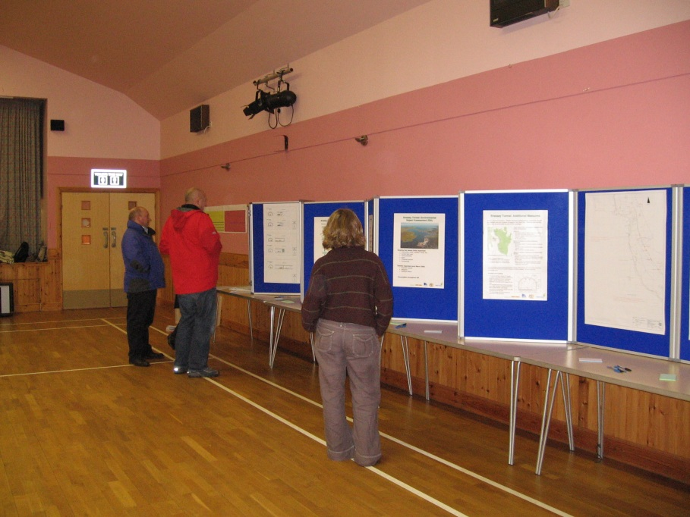
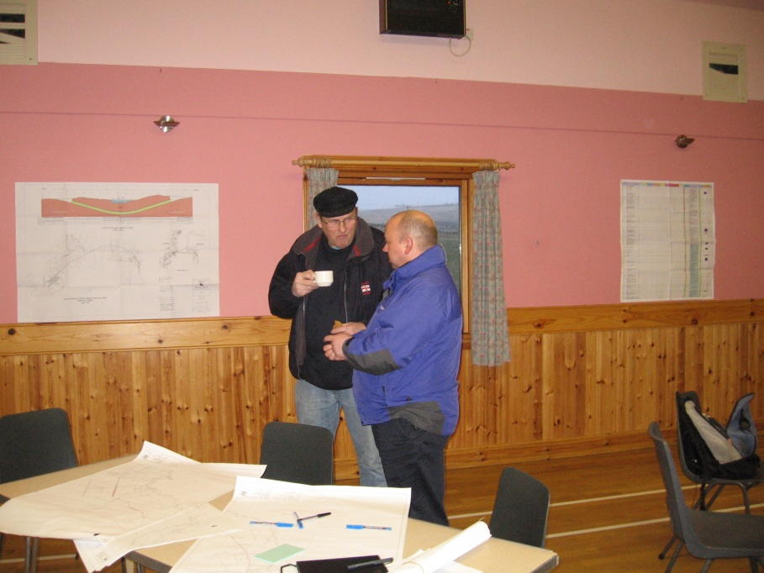

Comments and Feedback at Public Exhibition

Written Comments (post-its, plans etc)

Council Recommendation
- This option is still discrimination – old people, young children and disabled could not get to Lerwick independently (i.e. walking, cycling)
Short Term Measures
- Ferry fares and current impact on island’s population and development – action is essential as soon as possible
- Times to suit fish factory in the morning
- Early services for school
- 530am start to 930pm finish
- Post bus flexible but only fits 2 people
- Dial a ride
- Post bus is not advertised
- National Health Service does not refund Bressay Costs to attend hospital, but do in Unst
- Community bus option in the meantime is an excellent idea – however would require more seats than proposed

Consultation
- Bressay Primary School
- Bressay Parents Council
- Planning Department etc – impact of a tunnel could have huge consequences for housing – this ‘development’ needs regulation
- Will the existing Local Plan still stand if the tunnel goes ahead (thinking of building houses etc)

EIA
- Flood protection

Funding
- Will there be a toll charge on planned tunnel?
- Why should there be a toll?
- Will the LPA pay commercial rate for spoil for reclamation or just get it as a subsidised freebee?

Additional Measures
- Bus would need to be frequent – i.e. beyond commuting times. Given the health etc facilities are in Lerwick
- It would be helpful to have pedestrians/ vehicles on drawing to show scale
- Sufficient cycle/ footpath in tunnel – what about safety at either side?
- Single track road and large vehicles – unsafe
- No mention of times the Anderson High school pupils will have to leave and when they will return and collection points

Safety
- Who wants to cycle through a tunnel?
- Opportunity to see geological features – can we see exposed rock rather than sprayed concrete
- The public should be made aware, as well as Shetland Islands Council (SIC) representatives, of the known dangers of tunnels – the history of when things go wrong etc – these risks should be made explicit in the feasibility study
- Joy-riding could be a big problem

Future Work
- How we can keep to schedule!

Road Plans
- What would happen to the ferry terminal – would it be destroyed or maintained?

General Comments
- The tunnel will double carbon emissions
- Cycling and walking opportunities that currently exist will disappear
- This project will effectively end pedestrian and cyclist access to central Lerwick. At present many people walk or cycle up to 2 miles to the ferry terminal at Maryfield, mostly on gentle gradients. No-one can seriously suggest that as many cyclists and pedestrians (let alone more) will wish to cycle an extra three miles up a steep hill, along an exposed 200m ridge, down past a smelly fish factory, through a single lane tunnel full of exhaust fumes, emerging into heavy industrial traffic in the north of Lerwick, where there are no cycle paths and few footpaths. This compares with the existing seven minute, half mile ferry ride to the town centre. This is a major disadvantage of the proposal that no amount of semantic engineering can conceal
- Road safety will be adversely affected for pedestrians/ cyclists
- The project will greatly increase Bressay’s (and Shetland’s) production of CO2, as the doubling (at least) of vehicular traffic emissions will greatly outweigh the reduction from stopping the ferry service
- A ferry shuttle service from 0530 to 0130, staffed to sensible legal MCA levels, would be greatly preferable, achieve the same aims and attract a 64% subsidy from the Government
- There is no SIC budget for this and, in the present financial situation on prospect of one.

Verbal Comments to the Bressay Project Team

- Concerns re: loss of walking opportunities on Bressay
- When is short-term for measures?
- Something should be delivered on short-term measures as soon as possible
- Information on feedback from consultation should be on web-site. Web-site link should be advertised in the newsletter
- Concern re: carbon issues if generate increased traffic
- Request for ballot
- What is a sustainable solution for a small island community?
- Could a dry dock be constructed with the tunnel waste?
- Issues of access to Leasks bus depot-take into account in the design
- What renewables measures can be built in to the design?
- Any opportunity for access shafts in the tunnel?
- Worries that there will there be unmonitored housing development on Bressay

Approximate numbers only – no formal record kept

