Shetland’s Transport Priorities for the Next Scottish Parliament
Shetland’s communities depend on reliable, affordable and resilient transport connections — within our islands and to the Scottish mainland. These connections underpin everyday life, community cohesion, economic activity, access to healthcare and education, and the long-term sustainability of island communities.

Shetland’s geography, climate and dispersed population mean transport here is a lifeline and cannot be treated as discretionary or viewed through a one-size-fits-all lens. Practical, place-based solutions are essential. ZetTrans brings together elected members of Shetland Islands Council, NHS Shetland and HIE Shetland to plan and deliver those solutions, working in partnership with Transport Scotland, operators and communities.
As parties prepare their manifestos for the 2026 Scottish Parliament election, ZetTrans asks that Shetland’s specific needs are recognised and reflected through the following priorities.
OUR ASKS
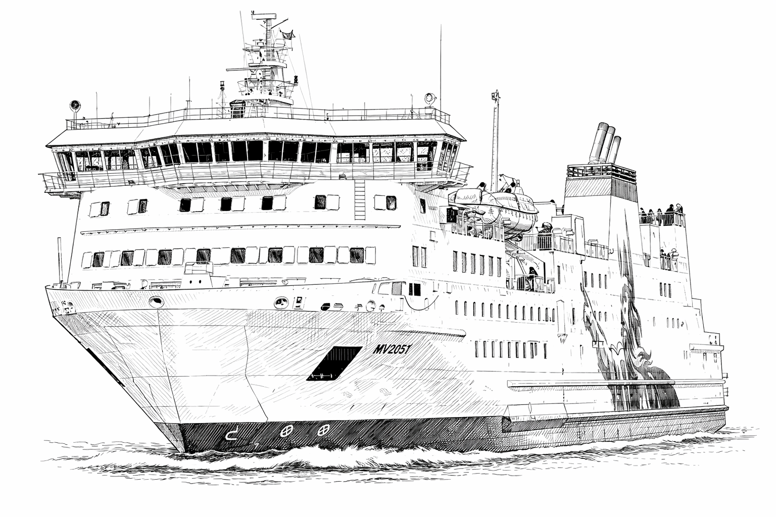 | 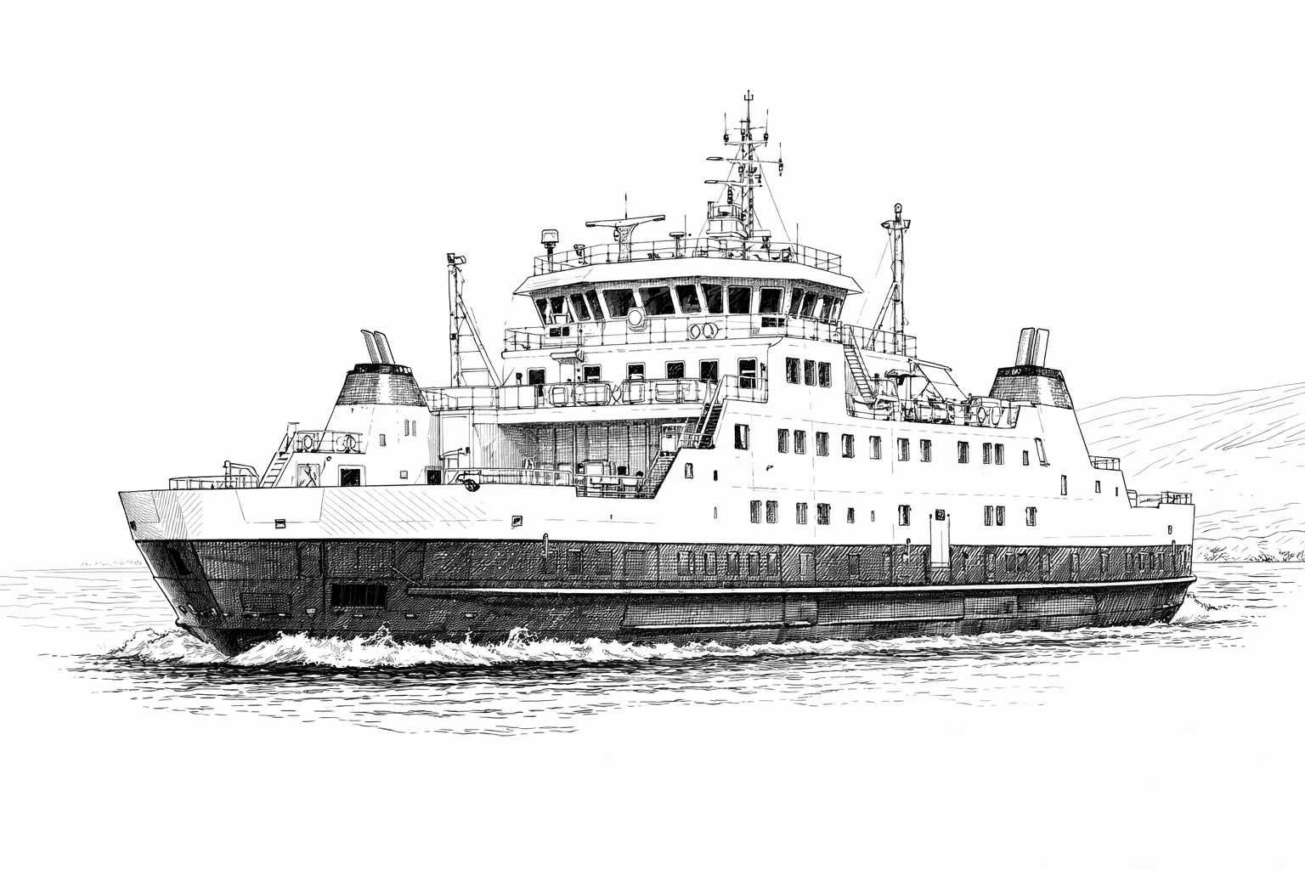
1. Keep Shetland connected — to the Scottish mainland and beyond  Reliable air and sea connections are lifeline services for Shetland. Communities and businesses depend on safe, affordable and resilient links to mainland Scotland and beyond.  We ask the next Scottish Government to:  - Commit to sustaining and strengthening Shetland’s air and ferry links as essential public services.  - Work with ZetTrans, operators (including ferry and aviation operators, and ports and airport operators) and communities to ensure services meet local needs and support the island economy.  - Recognise the strategic importance of Shetland’s connectivity to nationally important sectors including energy, aquaculture, tourism and space. | 2. Make the right long-term investment in inter-island transport infrastructure  Connectivity between Shetland’s islands depends on resilient and fit-for-purpose infrastructure. Different routes require different solutions.  We ask the next Scottish Government to:  - Support the completion of a strategic, network-wide business case and the development of subsequent route-specific outline and full business cases to identify the most effective long-term solutions for each route.  - Keep all options on the table — including ferries, piers and fixed links — and commit to evidence-led decisions rather than prescriptive approaches.  - Work with ZetTrans to turn agreed solutions into deliverable investment programmes.
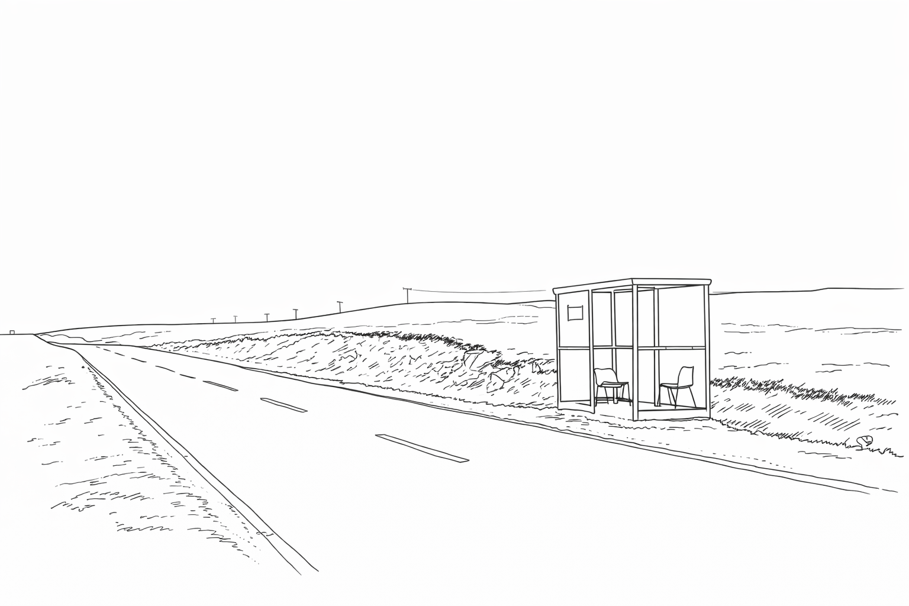 | 
3. Strengthen everyday transport that people rely on  Buses are essential to daily life in Shetland, supporting access to employment, education and healthcare. Our bus network is planned and contracted locally and delivered by small, local operators, but service resilience is under increasing pressure.  We ask the next Scottish Government to:  - Support sustainable, long-term funding for rural and island bus services and associated infrastructure that reflects social and economic value, not just passenger numbers.  - Continue to involve ZetTrans in fare policy development, including future fare cap approaches.  - Build on recent zero-emissions bus trials and support fleet transition to net-zero public transport where it is practical and deliverable in island conditions.  - Recognise the challenge of reducing car dependency in island and ultra-rural areas and support realistic and proportionate approaches. | 4. Invest in sustainable travel infrastructure an island climate  Shetland’s wet, windy climate and exposed geography shape how people travel. We can’t change the weather, but infrastructure can be improved.  We ask the next Scottish Government to:  - Commit to consistent, multi-year investment in walking, wheeling, cycling and public transport infrastructure designed for island conditions.  - Move away from short-term, ad-hoc funding rounds towards planned programmes of investment.  Support locally relevant infrastructure that enables more people to choose walking, wheeling and cycling where it is realistic to do so, rather than the inflexible application of urban assumptions to island and rural contexts.
Delivering for Shetland
These priorities are achievable. ZetTrans is already working with Transport Scotland, operators and communities to plan and deliver transport solutions tailored to Shetland’s needs.

By backing these priorities, the next Scottish Government can:
- Fairly support island transport and mobility in a practical way.
- Deliver visible improvements within the next parliamentary term.
- Strengthen national outcomes on inclusion, resilience and net zero through place-based delivery.

ZetTrans stands ready to work with any incoming government to keep Shetland moving.
Cllr Moraig Lyall, Chair, Shetland Transport Partnership

